# A CRM APPLICATION OF SCHOOLS AND COLLEGES

**INTRODUCTION**

Overview

[A school CRM (Customer Relationship Management) software is a specialized tool designed to manage and track student interactions, data, and automate tasks related to student recruitment, enrollment, and retention. Additionally, by personalising communication and providing automated follow-up, educational organisation can build better relationships with students and leads, and keep them engaged over time.](https://www.nopaperforms.com/blog/what-is-school-crm-software-and-how-it-helps-in-increasing-admissions/)

[Purpose  It helps schools and preschools in managing student data and](https://www.nopaperforms.com/blog/what-is-school-crm-software-and-how-it-helps-in-increasing-admissions/)

[Interactions, automate tasks related to recruitment and entrollment, and](https://www.nopaperforms.com/blog/what-is-school-crm-software-and-how-it-helps-in-increasing-admissions/) improve the efficiency of their recruitment and retention efforts. It can also

help to increase the effectiveness of enrollment compaigns.

**PROBLEM DEFINITION & DESIGN THINKING**

Empathy map

Empathy mapping is tool that really helps you get to know your customers. By understanding what your customers think, feel, say and do you can develop rich insight which helps you to identify genuine issues, problems or concerns that your customer may have right now.

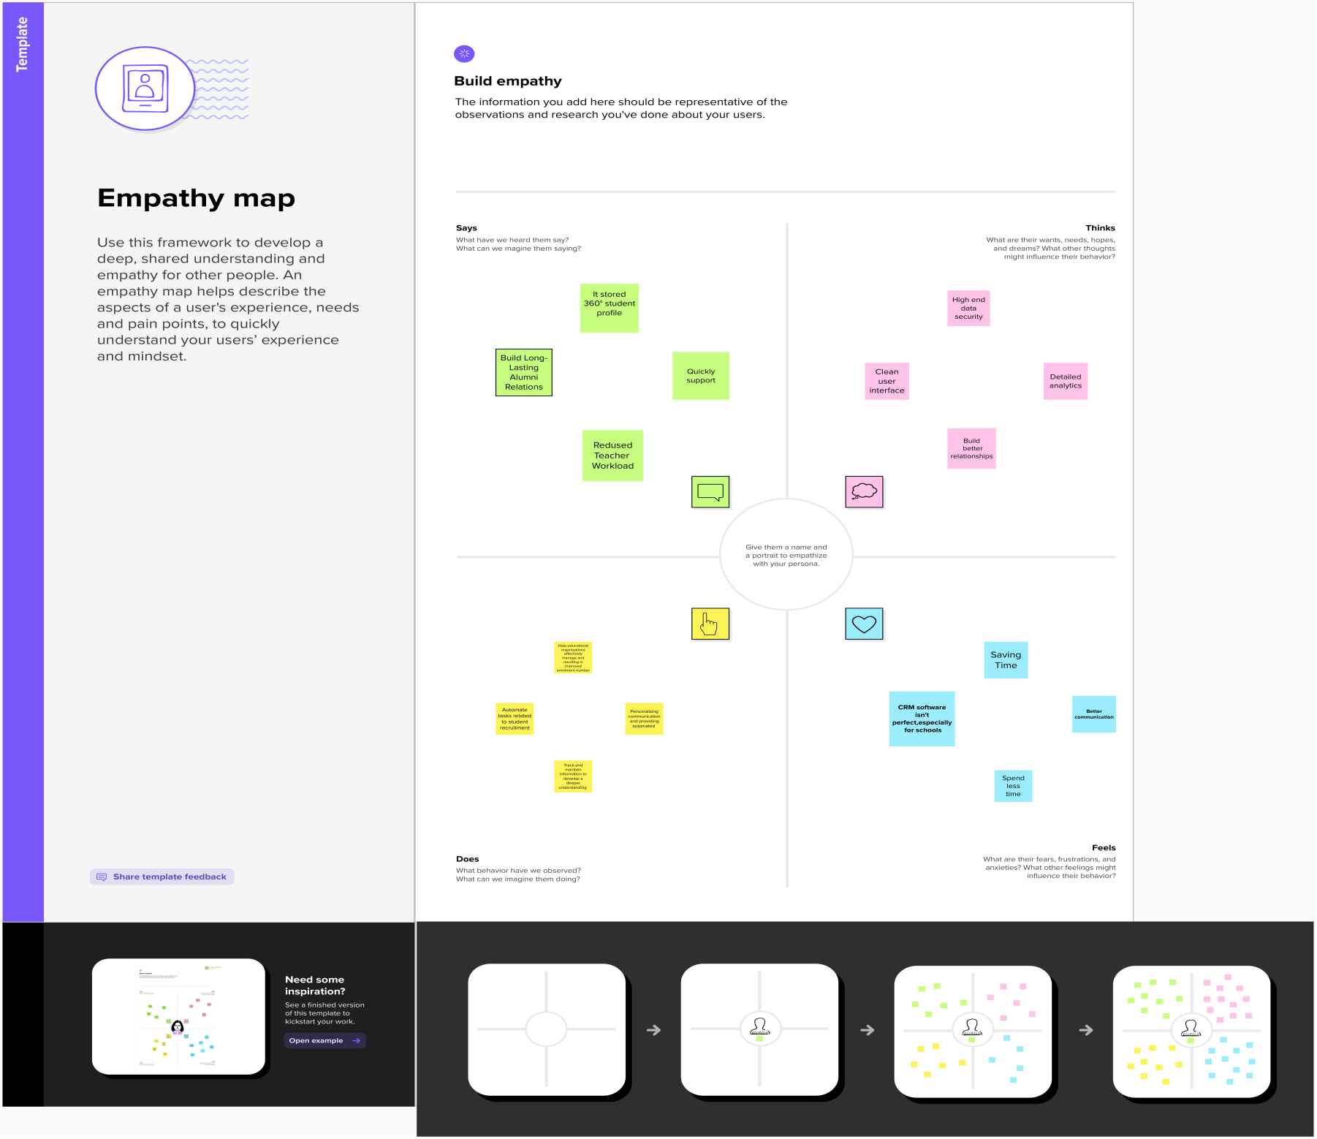

Ideation & Brainstorming Map

Ideation is often closely related to the practice of brainstorming, a specific technique that is utilized to generate new ideas. A principal difference between ideation and brainstorming is that ideation is commonly more thought of as being an individual pursuit, while brainstorming is almost always a group activity.

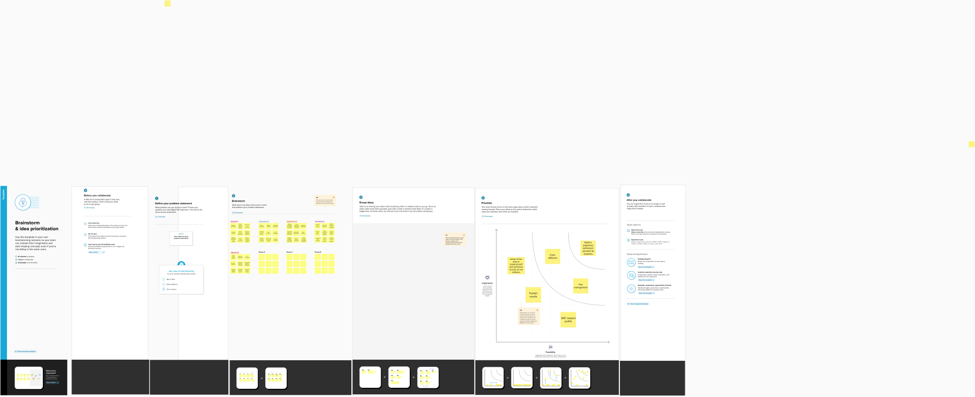

**RESULT**

Data Model :

|  |  |  |
| --- | --- | --- |
| **Object name** | **Field label** | **Data type** |
| School object | * Address * District * State * School * Number of students * Highest Marks | * Text Area * Text Area * Text Area * Text Area * Roll-up summary * Roll-up summary |
| Student object | * Phone Number * School * Results * Class * Marks | * Phone * Master-Detail Relationship * Pick list * Number * Number |
| Parent object | * Parent Address * Parent Number | * Text Area * Phone |

Activity & Screenshots

1.Creating Developer Account

* Go to the mail inbox
* Click the verify account

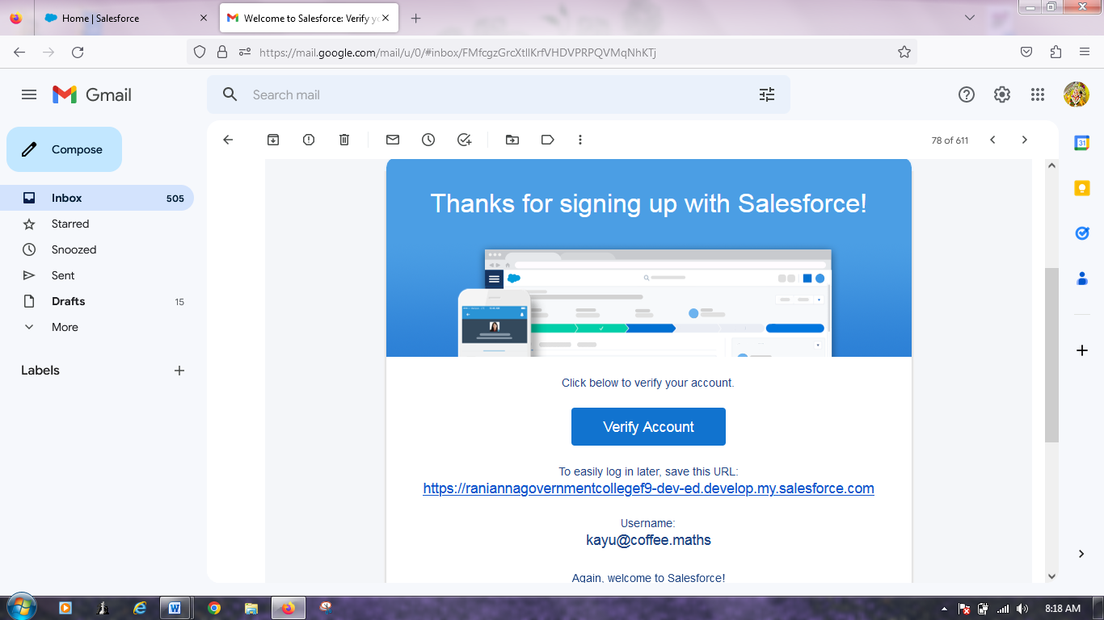

* Go to login.salesforce.com
* Enter the username and password and click login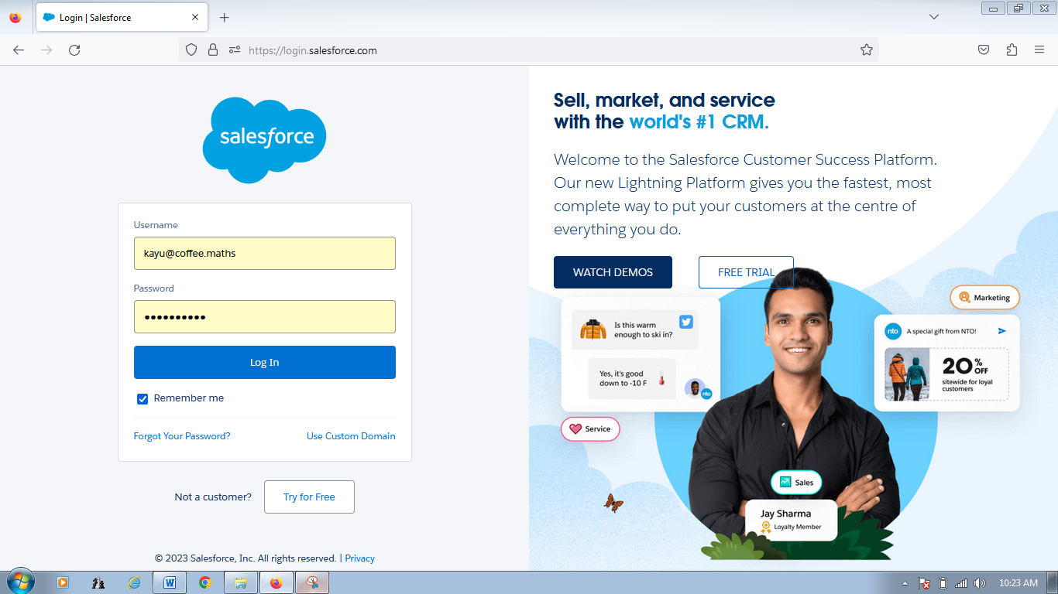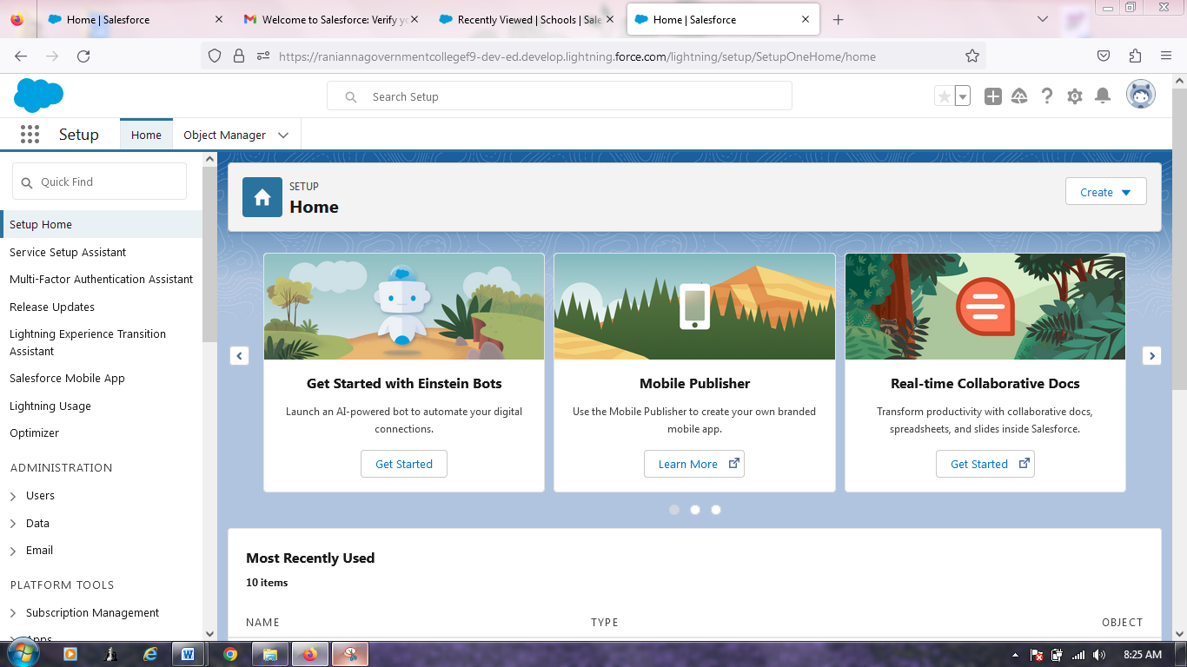

2.Object

* Now create school,students and parents object for school management
* And create custom tab for this three objects

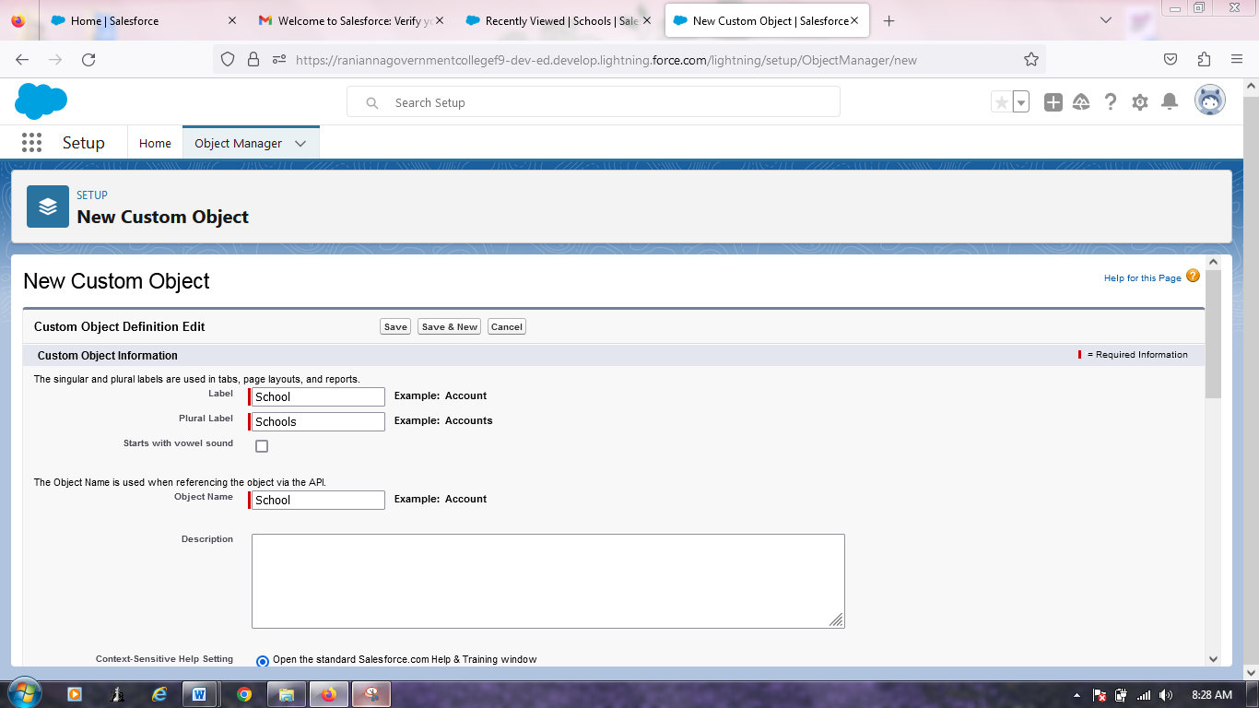

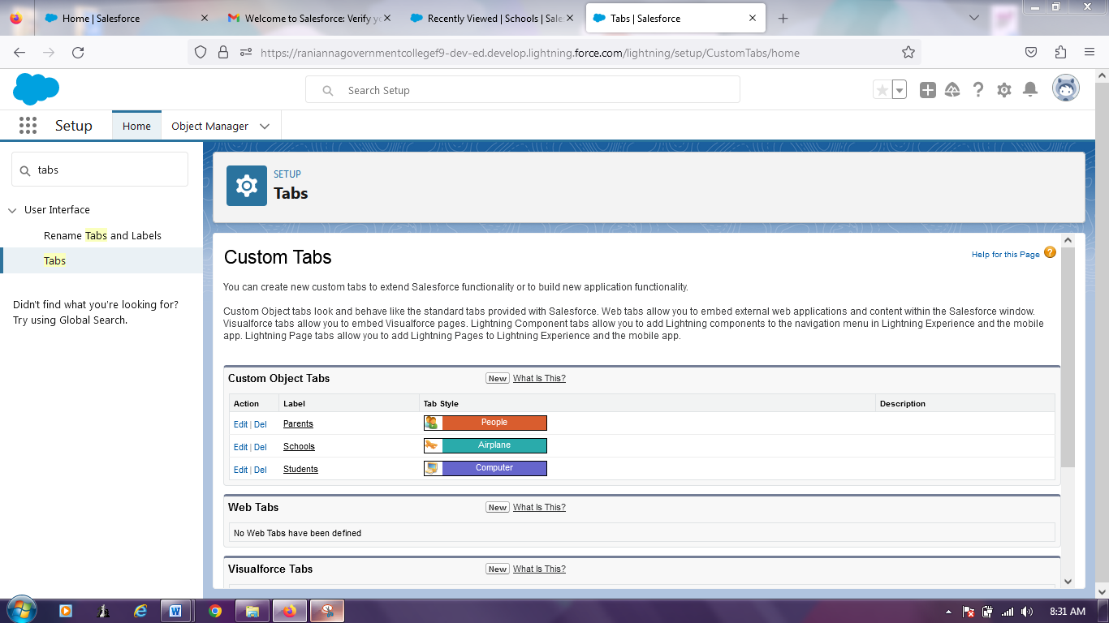

3.Lightning App

* Create the school management app from this items Schools, Students, Parents,Reports and Dashboards and System Administrator from profiles

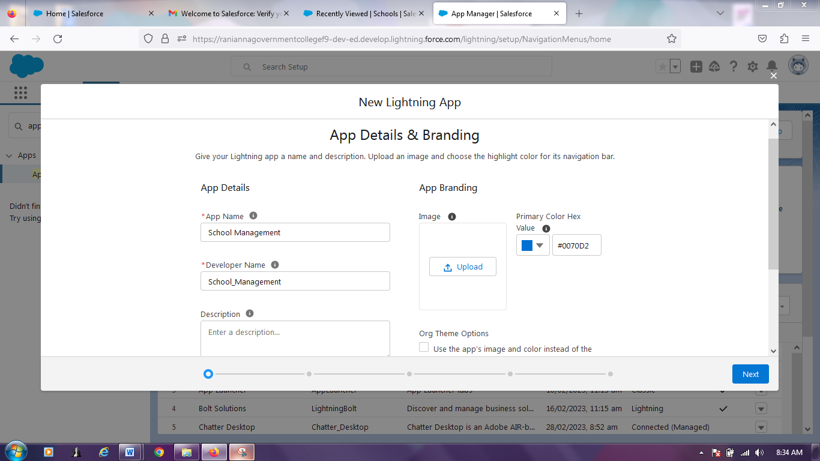

4. Fields and Relationship

* Now creation of fields for the school objects
* From this field label ie., Address, District, State ,School websites, Number of students and Highest mark

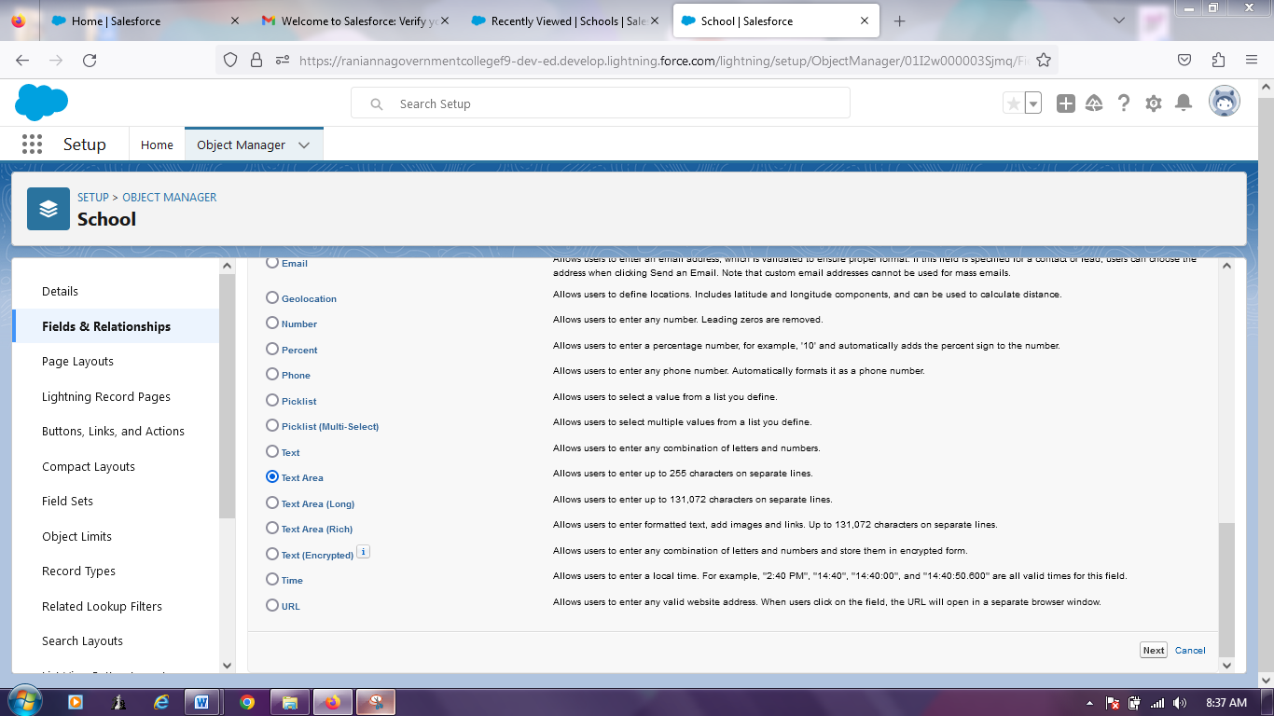

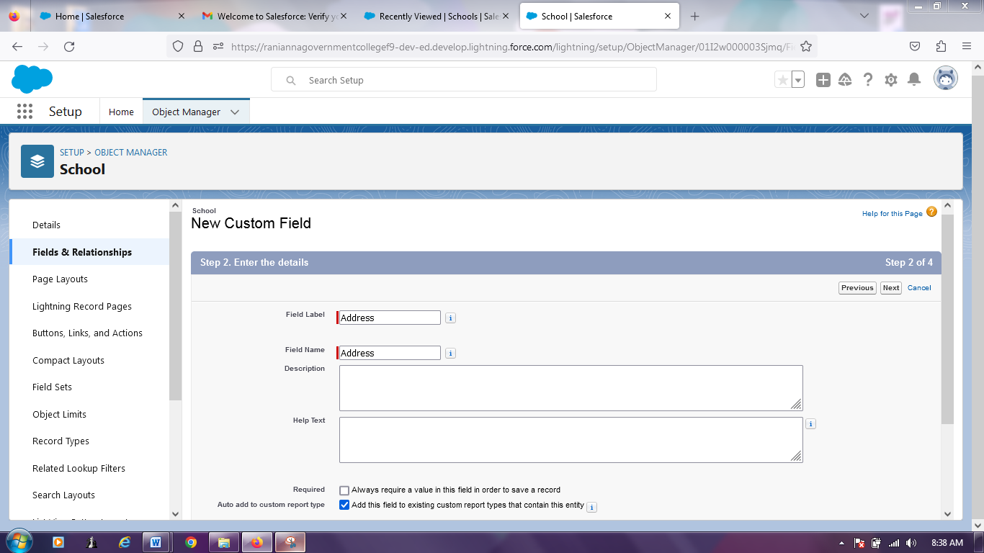

* Similarly,Now creation of fields for the student objects
* From Phone number, Results, Class and Marks as the field label
* And also creation of fields for the parent objects
* From Parent address and Parent number as the field label

5.Profile

* Now create School profile, first from setup select profiles
* And go to Standard user then click clone
* Enter School profile as profile name then save and edit to give view all access permission
* And similarly create Parent profile

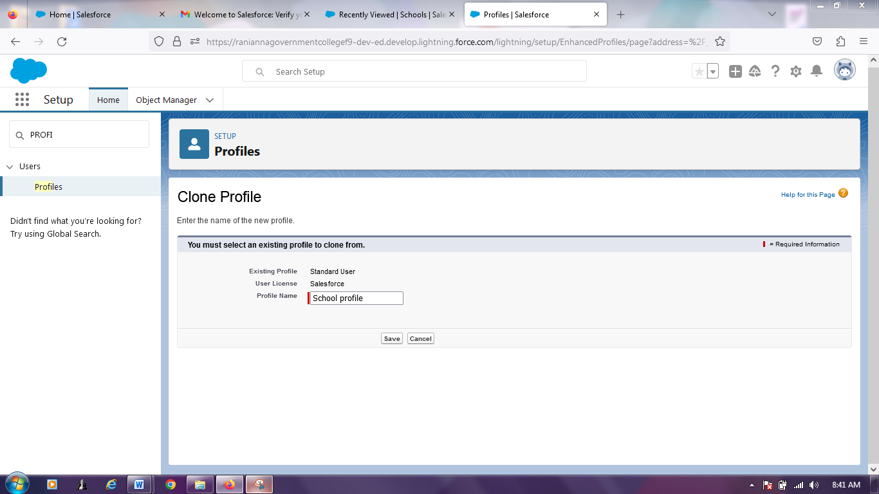

6.Users

* Creating a users
* From setup, select Users and click new user
* Create parents as a user’s name
* Select a User License as salesforce and a profile as a school profile
* In the similar way create users as Teachers and Principals

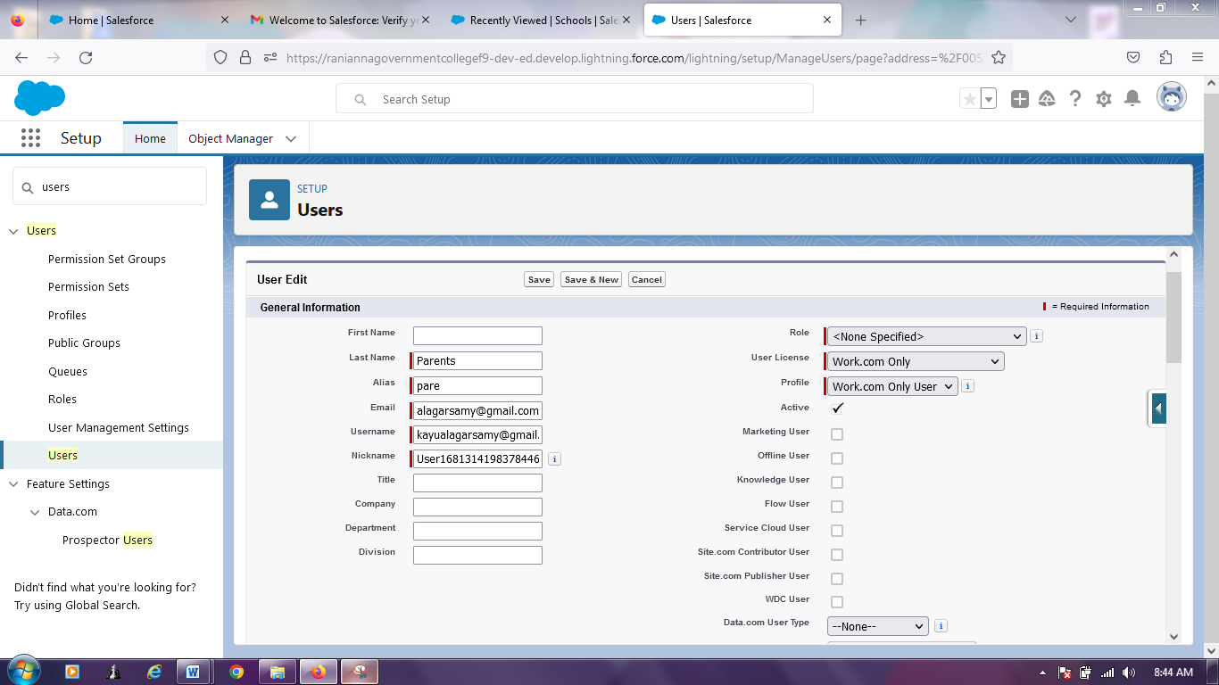

7.Permission sets

* Now create Teacher permission set
* From setup, select Permission sets and click new
* For the label, give teacher permission then save
* And give all permissions for custom objects
* In the similar way create Principal permission

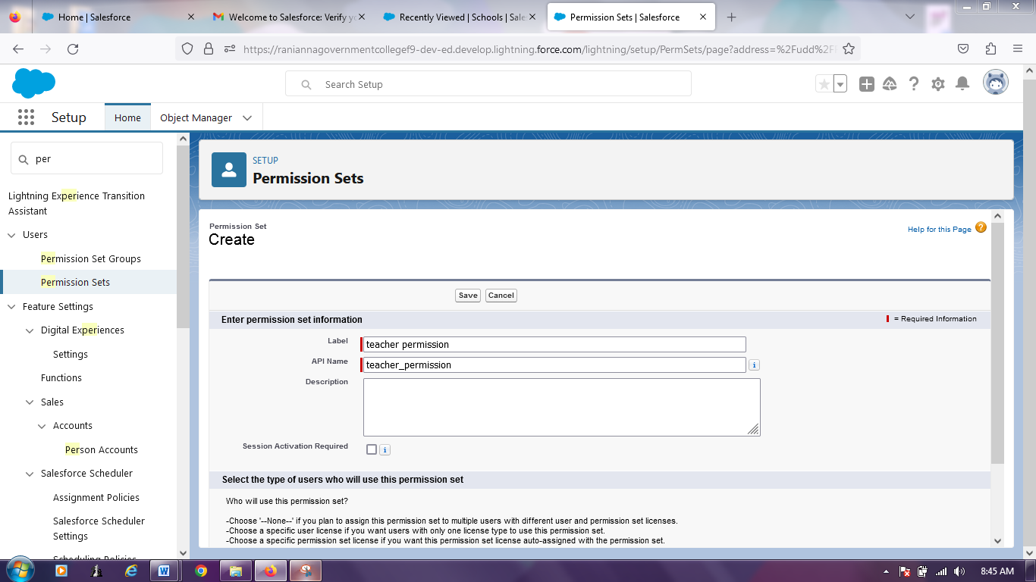

8.Reports

* Now create Reports
* From the Reports tap ,click new Report
* Go to the Report type and select School with students and click start Report
* Then save
* Similarly create Parent Report

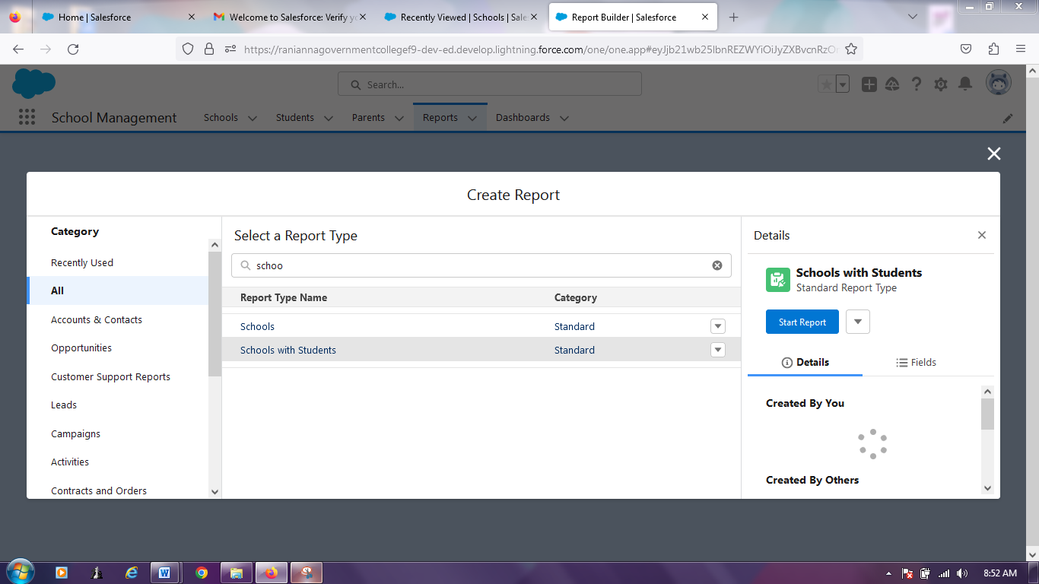

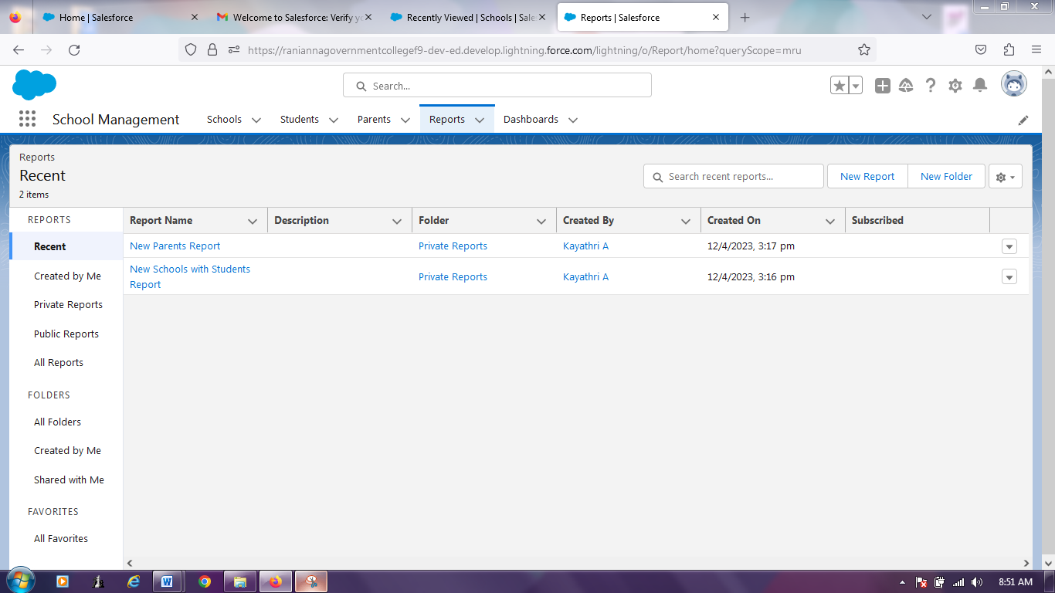

**Trialhead Profile Puplic URL**

Team Lead: <https://trailblazer.me/id/kayaa5>

Team Member 1: <https://trailblazer.me/id/kanig6>

Team Member 2: <https://trailblazer.me/id/rajar3>

Team Member 3: <https://trailblazer.me/id/souns15>

Team Member 4: <https://trailblazer.me/id/vijas52>

**ADVANTAGES &DISADVANTAGES**

Advantage:

### History of work with each student:

This is benefit of CRM in the education industry. We are accustomed to the fact that our desires are foreseen, and post-sales support is available at any time of the day. Implementing such processes is impossible without a CRM platform, because it has a separate card for each client with full information about the student. This data is presented in chronology, and you can view the entire history of work with the client in a couple of minutes.

Disadvantage:

One of the greatest challenges to CRM implementation is cost. There are dozens of software options available and many pricing plans that go with them. To work out the actual costs of CRM software, make sure that you consider the total cost of ownership including:

* software subscription or purchase fees
* premium upgrades, eg add-on marketing or reporting features
* customisation
* IT resources needed
* hardware or software requirements
* staff training and upskilling

Other factors such as data migration and quality, and converting business operations may also affect the total costs of CRM implementation. Proper planning and careful assessment of any potentially hidden costs should help you set a realistic budget for your CRM project.

**APPLICATIONS**

1. Application 1: Tracking Customers.
2. Application 2: Collecting Data for Marketing.
3. Application 3: Improving Interactions and Communications.
4. Application 4: Streamlining Internal Sales Processes.

**CONCLUTION**

Customer Relationship Management enables a company to align its strategy with the needs of the customer in order to best meet those needs and thus ensure long-term customer loyalty.

**FUTURE SCOPE**

Customers will become a company's best sales reps through superior products and services as well as customer-oriented messaging. The future of CRM is more than just the future of Customer Relationship Management software. It is really the future of business.